Revision and Exam Guide





Supporting Young Adults Through Exams

It’s exam season again, and it can feel like it’s come around very quickly. This is often a worrying time for young people and their parents, as stress and burnout are common, but there are ways to help.

Managing expectations is key to your young adult’s wellbeing. Let them know they don’t have to be perfect to succeed, and remind them that while exams matter, there is life after them and always other options to reach their goals.

Reassure your young adult that feeling anxious or stressed about exams is normal and that they are not alone. Let them know you are there to support them. Although exams can be challenging, they can also help build resilience and useful skills for the future.

There are many ways to support your young adult through exams, and staff are here to help.



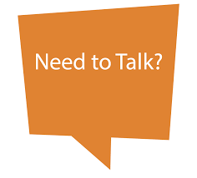
How to Offer Support

- Create a safe space for them to share their feelings.

- It may be useful to talk about the following:

  - How do they feel about the exams?

  - How do they want to plan their revision? They should have control and choose the approach that works best for them.

  - What are their revision strategies? You might want to work together to look at different methods (see ‘Revision Tips’)

  - Is there a quiet, comfortable space at home with few distractions? It’s best not to revise in the same room they sleep in, but if this isn’t possible, pack revision materials away when they are trying to sleep.

  - What time of day do they prefer to revise?

  - Do they prefer to study alone or with friends? Working with friends can help them share worries, enjoy learning, and stay motivated.

  - Are there any apps they want to download, or software needed?

  - Are there any resources they need?

  - What role would they like you to play in their revision? Could you test them, listen while they explain topics, or help remind them about extra revision sessions?


- Give reassurance and encouragement. Let them know you notice their effort, as this can help them open up and ask for support.

- Avoid nagging and try not to be critical. Let them know you believe in them and that you’re proud of their efforts.

- Go to support meetings offered by college. If you have any questions, contact subject tutors, progress tutors and learning mentors

- Make sure you know their exam dates and times

- Help them to keep on top of work, but also factor in fun, rest, and relaxation. Get them to take regular rest breaks. Get them outside, if possible

- Encourage them to create and follow revision timetables. AI, or college staff can help with this
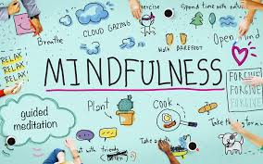
- Make sure they are eating, drinking, getting enough sleep. Offer healthy snacks as much as possible and make sure they stay hydrated


- Sleep is vital for wellbeing. Try relaxation techniques like yoga, mindfulness, or breathing exercises (many are available on YouTube).

- Your young adult may like the use of affirmations to boost confidence which they can have on their phones as reminders

- Remind them of college support (tutors, progress tutors, learning mentors, counsellor). There are also enrichment sessions that focus on exam preparation, mindfulness techniques etc

- Plan a treat together for when the exams are finished

Revision Tips
The most effective way to approach revision and exam preparation is to think about QUALITY rather than QUANTITY. It is best to work in short periods of time and complete focussed, effective work than sit for hours and achieve little.
The Pomodoro Technique
Developed in the late 1980s by Cirillo to help manage overwhelm and improve focus while studying. Cirillo used a tomato-shaped kitchen timer (pomodoro means tomato in Italian).

How it works:

- Work in 25-minute focused sessions
- Take a 5-minute break after each session

Purpose: Breaks work into manageable “chunks” to improve focus and productivity.

Benefits:
- Aids concentration
- Supports structured, focused, and effective task completion
- Particularly helpful for neurodiverse students

Key considerations:
- Tasks should be clear, specific and achievable
- Students should be encouraged to set realistic goals for each session

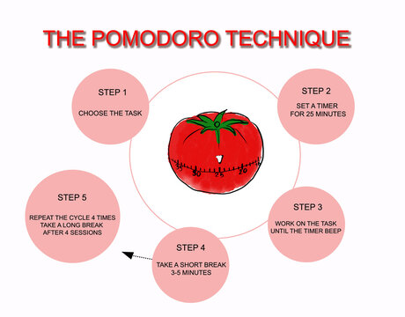)

It is advisable that they use a range of strategies to keep revision interesting and engaging. Some examples of revision techniques can be seen on the next few pages:

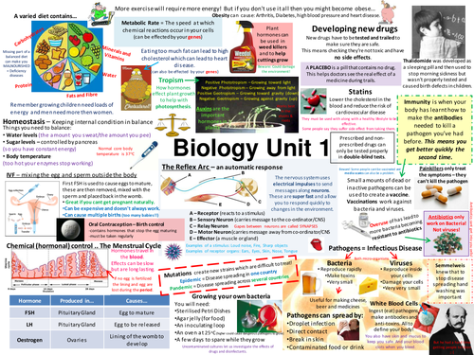
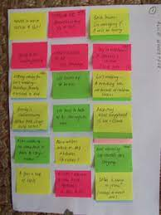
Posters Post-it-notes

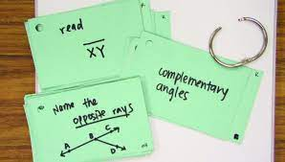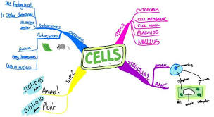
Revision cards (colour coded) Mind Maps (colour coded)

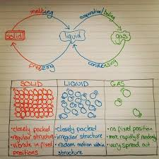

Drawing diagrams / graphs Online videos
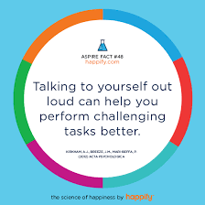
Voice notes Saying things out loud to themselves



Explain what they are learning to family /friends. Family can test them.




Genrate Flashcards



Use AI to:
- Summarise notes into key points
- Generate flashcards
- Explain difficult concepts in simple terms (with examples)
- Generate exam style questions
- Turn notes into memory aids (mnemonics / acronyms)
- Compare and conrast topics in tables
- Explain command words
- Make synoptic links between topics
- Create diagrams


Revision group with friends

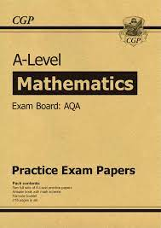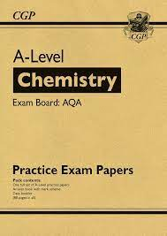
Past paper questions (using notes at first but then under exam conditions). Using mark schemes to help them grade the paper or ask their teacher to mark it

Their favourite revision method may not have been mentioned here. They need to use the revision method that best suits them
Also see section ‘Online Support’ for links on revision and exam preparation


The Night Before and the Day of the Exam

- Remind them how hard they have worked and how proud you are, regardless of results. There IS life after exams and there are ALWAYS options if exams do not go according to plan

- Avoid last minute revision. Encourage them to review work and then relax, so they are prepared for the next day

- Make sure their bag with equipment needed is packed and placed at the door the night before. Make sure they have their college ID.

- They need to be in comfortable clothing as exams can be long. It may be warm outside, but it can be cold in exam rooms. Advise them to take warmer clothing they can put on

- How are they getting to college? If they have extra time and it is an afternoon exam, how will they be getting home? These could be major concerns for them so make sure you discuss it and ease their worries

- Encourage relaxation, like listening to music or podcasts.

- Make sure they have something to eat before the exams or give them snacks to take. Make sure they have bottled water (with no label)

- Give them space after the exam. They’ll share when ready

- After an exam, congratulate them, show pride and support

- Prepare their favourite meal for them / have their favourite snacks

- Let them relax and engage in hobbies they enjoy as they will probably be tired


Signs That Your Young Adult May be Struggling and Support Available
At home
- A change in their ‘normal’ behaviour (can be a subtle or major change), e.g., they may change from being outgoing, to uncharacteristically quiet
- May stay in their room more than usual
- Changes in appetite (eating less or eating more, particularly junk food)

- Not sleeping
- Difficulty getting them out of bed
- Not socialising with friends (either online or meeting in person)
- Going out more with friends and avoiding college work
- Using social media more
- Difficulty getting them to focus on college work
- Mood swings
- Constantly talking about exams or not wanting to talk about them
- Self-injury

In college
- Non-attendance
- Late to class
- Distracted in class, withdrawn, quiet, not engaging in class work

- Not completing i270 work, coursework, assignments
- Grades have declined
- Avoiding support sessions
- Dismissive attitude ‘I don’t care about exams’ which could be a sign of anxiety
- Tearful – very worried about exams and always wants to talk about them
If you are worried about your young adult:

- Talk to them – if they will share their concerns with you that’s great. If not, will they talk to a friend, a teacher, a learning mentor, their Progress Tutor, college counsellor, the chaplain etc.

- Contact college to raise your concerns with their progress tutor / tutors / learning mentor(s)

- Look at the support available online (see later section ‘Online Support’)

Remember, staff are here to support you in ANY way we can. Keep in touch so that we can help you and your family

Online Support
Revision and Exam Preparation
The University of Birmingham has created a set of support materials focused on effective revision.
- A revision-style quiz to help students identify what type of reviser they are.
- Based on quiz results, students receive personalised study tips tailored to their revision style.
- Sections on revision tips for students with dyslexia, ADHD
- AI and revision
- Effective revision strategies
- Exam preparation techniques
- Time management: managing workload and study schedules
- Links to recommended apps and digital tools designed to help students revise more efficiently.
- Dealing with exam stress
Click on the links below for further information
Exams and revision help | Birmingham City University
Time management tips for revision - Exams and Revision | Birmingham City University
Best AI tools for revision - Exams and Revision | Birmingham City University
ADHD revision tips from students - Exams and Revision | Birmingham City University
Revising with dyslexia - Exams and Revision | Birmingham City University
How to revise with the blurting method - Exams and Revision | Birmingham City University
Best apps and AI tools for revision and studying - Exams and Revision | Birmingham City University
Dealing with exam stress - Exams and Revision | Birmingham City University
BTEC students - Exams and Revision | Birmingham City University

Emotional Wellbeing Support
The following list is taken from GOV.UK and is aimed at students and parents to help manage worries about exam and revision stress.
Advice for parents
YoungMinds is a charity working to improve emotional well-being and mental health amongst children and young people. See YoungMinds’ advice for parents.
NHS: See the advice from the NHS: Help your child beat exam stress.
Family Lives is a charity helping parents to deal with the changes that are a constant part of family life. See Family Lives’ advice for supporting your teenager through their exams.
Relate is a charity offering relationship support. See Relate’s advice for coping with exam stress as a family.
TheSchoolRun.com is a website offering resources to help learning at primary school. See their advice on helping your primary school child with exam stress.
Teenagers Translated is a website offering information to help parents understand their children during their teenage years. See their advice on managing exam stress.
Advice for children and young people
Childline is a service provided by the NSPCC offering confidential advice to children and young people. See Childline’s tips for beating exam stress.
YoungMinds is a charity working to improve emotional well-being and mental health amongst children and young people. See YoungMinds’ advice for young people.
Student Minds is a mental health charity for students. See Student Minds’ resources for dealing with exam stress.
Mind is a charity providing mental health support for anyone experiencing a mental health problem. See Mind’s 14 ways to beat exam stress.
BBC Bitesize offers resources to help students with homework, revision and learning. See Bitesize’s advice on how to deal with exam stress.
GoConqr is a personal learning environment to aid learning and revision. See GoConqr’s tips on how to deal with exam stress.
The Student Room is an education website offering peer support for students. See The Student Room’s advice on dealing with exam stress.

