16- 19 Student Bursary – How to Apply using PayMyStudent
College can be financially challenging for some young people. At St John Rigby College we want all our students to enjoy their College experience without this worry. The Student Bursary can help with the costs of travel, meals, kit & equipment, DBS checks, UCAS applications, essential trips and visits and other miscellaneous costs associated with attending St John Rigby College.
For more information about the different types of Financial Support available and who may be eligible for this support please read the 2026-27 Student Bursary and Free College Meals Guidelines and Information.

When can I apply?
Bursary Applications for 2026-27 will be available 24 hours after enrolment. New students who wish to apply for financial support from the Bursary Fund can submit an application form via PayMyStudent (PMS).

Who can apply?
Students are expected to complete the application form on PayMyStudent, but we strongly advise that a parent / carer supports them when they are doing so (unless the student lives independently). To complete the application form students will need to upload income evidence for ALL members of their household, except siblings who are in full-time education. Parents / carers will therefore need to support students with this process.

How do I apply?
Step 1: Registering and Activating Your Account:
Go to: The St John Rigby College
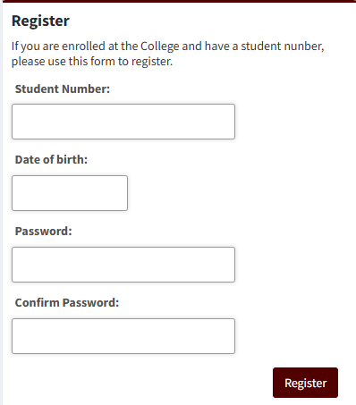
PayMyStudent runs most efficiently on a computer/laptop using Google Chrome rather than a mobile device. When you reach the landing page, you will see ‘Register’ on the left hand side. If you are using a mobile device, ‘Register’ will be at the top of the page.
Register with your student number (which you will be have been given during enrolment), date of birth and then create and confirm a password of your choice.
N.B. If you cannot find your student number please contact reception on 01942 214797 and they will be able to give you this information.
An activation email will be sent to your personal email address (this will be the email address used when you applied to St John Rigby College on Applicaa). The email should come from: bursary@sjr.ac.uk. Click the activation link in the email. This verification link is time sensitive, so you must ensure you do this within a maximum of 20 minutes.

Step 2: Logging In:
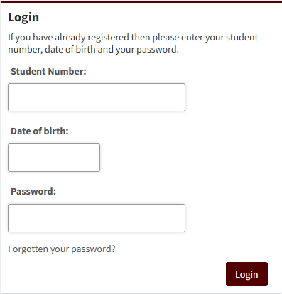
When you have registered and activated your PayMyStudent account, login using your Student ID Number, date of birth and the password you created.

Step 3: Completing a bursary application:
Once you login to the portal, the system will automatically provide the correct bursary application based on your age and date of birth. This ensures you are applying for the right funding at the right time.
After you have logged in, you will be able to select the blue button on the home page which says: ‘Click here to proceed with your bursary application’
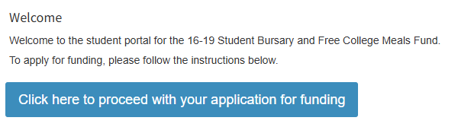

After clicking the above button you will be able to start your application for financial support.
Firstly, you will be asked to check your personal details – if everything is correct, please select “Next”, located at the bottom right of the webpage.
You will then be asked to enter a parent/carer’s personal details (if you do not live independently), please select “Next” when this has been completed.
The next stage requires you to answer a series of eligibility questions – please continue to work through the questions confirming your, and your household’s, information. When you are sure that you have answered all of the eligibility questions, please select “Next”.

After answering the eligibility questions, you will then be asked to upload the required evidence (based on the answers you have already given). It is very important that the evidence is suitable (please see ‘16-19 Student Bursary and Free College Meals Guidelines and Information’ for more details).
Applications without the necessary evidence will not be assessed. Incomplete applications may result in delays, and in some cases, may mean that you miss out on funding entirely. Given that bursaries are limited funds, it is crucial to provide the correct documents to avoid any unnecessary setbacks in the process.
After uploading ALL of the evidence, and selecting “Next”, you will then be asked to review your application to ensure that you have answered everything correctly and have completed all sections in full.

Step 4: Submitting a bursary application:
After you have reviewed your application, you will then need to carefully read the ‘Declaration’. This is extremely important as you (and your parent / carer) will be signing to say you agree to the contents of the declaration statement.
You then sign and date the application.
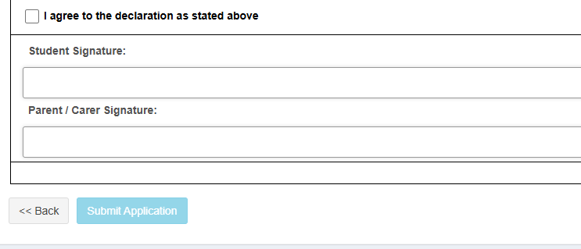
Unless you live independently, your parent /carer also signs and dates the document (the same parent/carer that you provided details for earlier in the application form).
The final action is to click the blue ‘Submit Application’ button
N.B. In some instances, additional questions may appear after you have pressed the submit application button (this only occurs if you have selected ‘other’ as an answer to one of the eligibility questions).

Once you have submitted the application, and answered any additional questions, your application will then go to the assessment phase of the process. St John Rigby College will contact you with the assessment decision as soon as is reasonably possible (or very rarely may ask for additional information /evidence).

Password Recovery
Step 1: On the login page, below the fields for email and password, you will see a Forgotten your password? link
Step 2: Enter your student number, ensuring you enter this correctly (the letter at the start of your student number needs to be a capital), date of birth and click submit.
Step 3: PayMyStudent will send you an email with instructions on how to reset your password.
Step 4: Once your password is reset, return to the login page, enter the required details with your new password, and click log in.

Contact Details
For any queries regarding this guide, PayMyStudent or bursary funding, please email bursary@sjr.ac.uk and we will get back to you as soon as we can. Please note that response times in September will be longer than usual whilst we are assessing applications.

